Reduced Functionality Prototype
Development Documentation
Written by: Michael Mascaro
Summer 2010
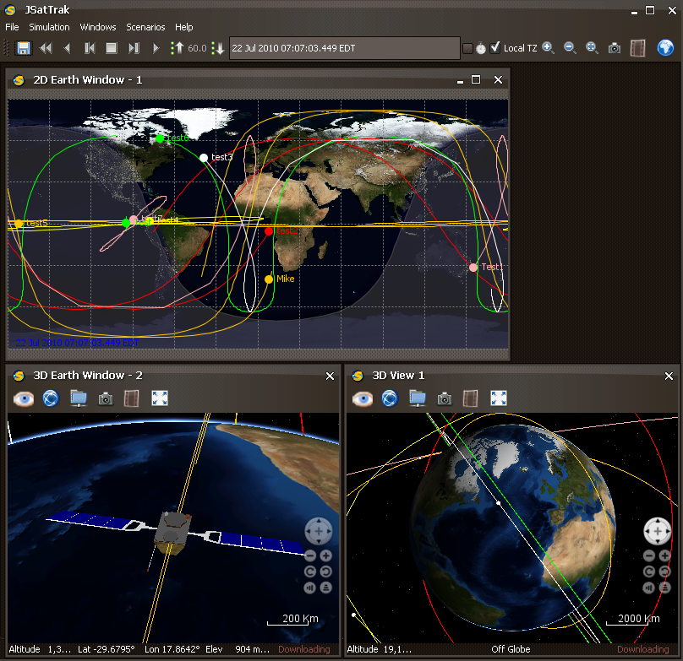

Table of Contents:
- Note to the Reader………………………………………………………………...1
- Introduction………………………………………………………………………..2
This section introduces the concept and purpose of the JSatTrak Reduced Functionality Prototype.
- Development………………………………………………………………………3
This section covers the development of both JSatTrak and the Reduced Functionality Prototype.
- Capabilities………………………………………………………………………..4
This section covers the capabilities of the Reduced Functionality Prototype.
- Graphical User Interface Changes………………………………………………...4
This section covers the changes made from the original JSatTrak and the Reduced Functionality Prototype in regards to the Graphical User Interface (GUI).
- Source Code Changes……………………………………………………………..5
This section covers the changes made from the original JSatTrak source code to the Reduced Functionality Prototype source code.
- Future Development……………………………………………………………
This section covers the future development plans for the JSatTrak Reduced Functionality Prototype.

Note to the Reader
Please note; this documentation is to serve as a supplement to “Using JSatTrak as a Visualization Tool.doc” This is not the complete documentation for the work done during the summer of 2010, merely an additional supplement to the complete documentation, which is located under the aforementioned file. Please read “Using JSatTrak as a Visualization Tool.doc” before reading this documentation.

Introduction
Using JSatTrak for visualization purposes in the CCS project is an effective tool, but JSatTrak contains many features that are unnecessary for the visualization goals required by CCS. In order to create a more user-friendly, embeddable version of JSatTrak that serves strictly as a viewer tool required a reduction of functionality from the original JSatTrak program. This documentation covers the development of the JSatTrak Reduced Functionality Prototype (RFP), which was developed to provide a prototype of a “view-only” mode of JSatTrak. This documentation will cover the development of the RFP, as well as both the removed and current capabilities of the prototype. Also included within this documentation are the exact changes made to the source code and to the graphical user interface to create the RFP. Development has lasted for four days to the moment this documentation was written, so this documentation will also cover future goals for further development of the RFP.

Development
The Reduced Functionality Prototype is developed from Shawn Gano’s JSatTrak. The RFP was created by editing and modifying his code. The changes described in “Using JSatTrak for Visualization” were applied to the original source code, and then further modifications were made to remove features and create the RFP. Primary development of the RFP during the summer of 2010 was by Michael Mascaro, with support from Stefan Novak of a.i. solutions. Development of both the original JSatTrak and the RFP are located on github (www.github.com) and can be found under http://github.com/mdmzero0/JSatTrak. All code changes and work was done in NetBeans and tracked using Git.

Capabilities
The primary goal of the RFP was to remove capabilities originally included within JSatTrak in order to make a simple, embeddable 3D viewer for satellite information. Therefore, the capabilities described here for the RFP are far fewer then the capabilities outlined in “Using JSatTrak for Visualization.” Some of the removed capabilities include:
- Tracking and coverage analysis tools
- Adding in Satellites from TLE data and custom satellites
- Terrain analysis tool
- Command shell scripting and log console
- Creating new scenarios

JSatTrak is still a powerful visualization tool, however, and still retains certain capabilities. These current capabilities include:
- Visualization of 2D groundtracks as well as 3D globes
- Opening of both xml and zip formatted scenarios
- Saving scenarios
- Reading both a start-up script and reading scripts as plugins
- Model-centered and Earth-centered view modes
- Fixed and inertial 3D Earth-centered views
- Interactive 3D and playback features
- Screenshots and movies created from scenarios

Graphical User Interface Changes
The most noticeable changes to JSatTrak in the RFP are the changes made to the graphical user interface (GUI). Since many of JSatTrak’s features have been removed, the corresponding icons and menu options have also been removed or changed. The icons and menus removed are:
- Under File menu: removed New Scenario icon
- Removed Utilities menu, except for Create Movie of Application icon
- Under Windows menu: removed Satellite Browser, Groundstation Browser, Log Console, Command Shell, and Command Shell Desktop icons
- Removed Satellite and Groundstation icons
- Removed Object List
- Removed Terrain Profiler from 3D windows
- Create Movie of Application icon moved to Simulation menu
- Plugins menu renamed Scenarios menu

The changes to the GUI are shown below, with the removed icons circled in red.
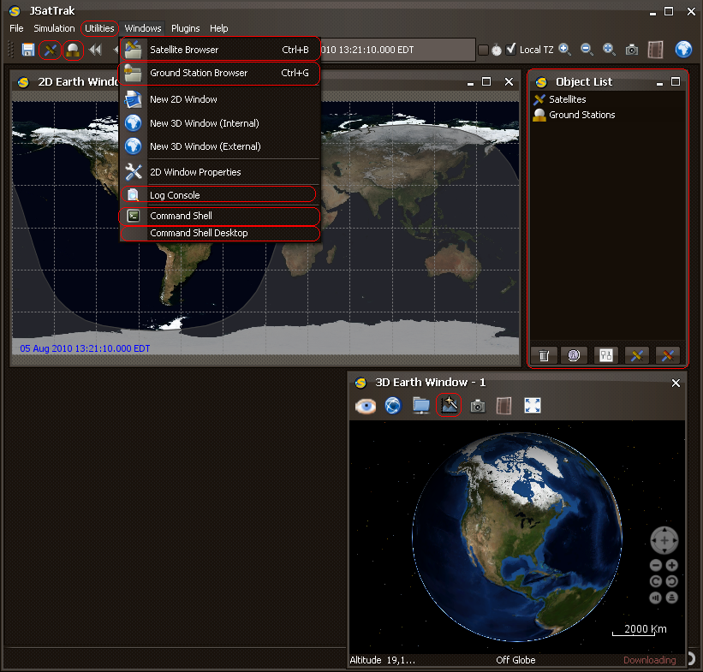

Source Code Changes
In addition to the removal of several icons and menus from the GUI, changes had to be made to the source code to remove some of the functionality of JSatTrak. None of the changes made to the source code involved removing lines of code; instead, unused lines of code were commented out to remove functionality while preserving the code itself. The code for the RFP include the changes made to JSatTrak’s source code during previous development (see “Using JSatTrak for Visualization”), despite those changes not being listed here. The following changes have been made to the JSatTrak source code to generate the RFP:
JSatTrak.java:
- Commented out lines 297, 450, 453, 2786, 3261, 3832
  - Removes the object list
- Commented out lines 360, 612-617, 2406-2449, 3141, 3295-3299, 3788-3791
  - Removes the coverage analyzer
- Commented out lines 2199, 3145, 3146, 3331-3334, 3398
  - Removes command shell
- Replaced “plugin” with “scenario” in lines 653, 658, 676, 687, 3460, 3483, 3492, 3493
Jcustomsatconfigpanel.java
- Commented out line 697
J3DEarthpanel
- Commented out line 321

J3Dearthinternalpanel
- Commented out line 315
JSTSaveClass
- Commented out lines 112-116, 160

Future Development
The next step for the RFP is to generate a java applet from the source code. This will allow the RFP to be embedded within a website and run directly off the web rather then downloaded to a user. This will then provide an accessible, interactive, and effective 3D visualization for CCS users.

